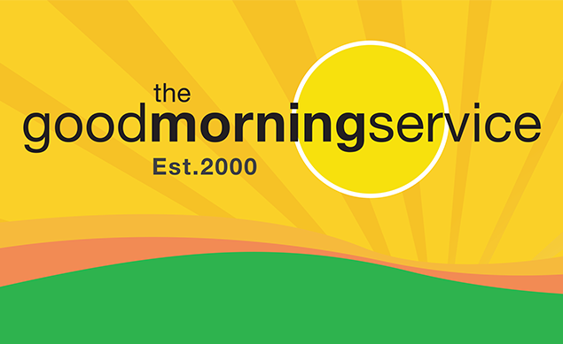
Client Referral Form

Call us on 0141 336 7766, email or post this form to refer or join.
We will phone to explain our social, emotional, and safety support
Good Morning Calls
and go through the application process.

Minimum age to join is 65 years.

About the Person Referred

Title: Name: DOB:

Address: Postcode:

Telephone: (a) (b)

We can also write to and call a nominated contact person to explain the Good Morning Service to help the person decide if the service suits them. If the person you’re referring thinks this would help please give their details here:

Name: Tel: Relationship:

Address:

Reason for referral:

Are there any cognitive problems diagnosed or suspected? Yes / No (If yes, please give info)

How did you hear about us?

Social work services _______ Health worker ________ Police Scotland ________

Friend / relative _______ Housing Assoc ________ Social media ________

Name of your dept/ team:

Will your organisation provide a service to this person during the next 6 months? NO YES

If yes, we might contact your organisation as part of our locating procedures.

If yes, but contact from us is not appropriate please tick here:

Your name: Tel:
(please print)

Date:

Befriending Manager, Good Morning Service, 4B Platinum House, 23 Eagle Street, Glasgow, G4 9XA

info@goodmorningservice.co.uk

Follow us on Facebook and Twitter @Good_Morning_2U. Updated October 2025.

Good Morning Project Ltd No.SC221598 Charity No SC031960 'Good Morning', 'Good Morning Project Ltd', associated logo are registered trademarks.

Impact: what matters to people?

“Sometimes you don't want to say to your family how you feel, but you can always tell
Good Morning. I can depend on that phone call every day and feel safer knowing that someone is always there.” Ella, 85 years

“After my knee operation I was feeling really low...but they made me realise that I still had lots of life to lead. And they always noticed my progress. It was really good to be reminded of how far I’d come because you don’t see it in yourself, I enjoy their daily encouragement.”

“I live my life differently because of it. It gives me some prompting to get on with life.” Janet, 72

“I'm not too well in the morning but when the phone rings and they say 'hello',
it is a better tonic right away than all the tablets I swallow.” Ann, 83 years

“I can depend on Good Morning. It gives me confidence to live alone knowing that if I desperately needed help, you are there.” Mairi

“We can have a laugh, I can share a problem, ask advice and they will help if they can.
If I worry about something or don't feel too well I have someone who'll listen.
That makes a big difference.” Margaret, 65 years

“The team have taken the time to get to know me and they're interested in what's happening in my life. As they actually ask me my opinion and seek my views I feel listened to,
and also valued.” Catherine, 82 years

“I've made a lot of new friends to blether to. And it's a great feeling to go to bed and know if I took ill during the night you are always there to help – it's security.” Nancy, 76 years

“After the call I feel good and can face the world and
all its problems, and mine too.” Clare, 72 years

“It makes you live your life because you are never really on your own. They make me feel like a person – not an old woman.
I can discuss things like politics and keep in touch with the world
– you just keep me going!” Charlotte, 90 years

“I really like to be independent and knowing Good Morning are there
should I need them makes life easy” - Sophia, 95 years

Question:

1. Did you know that having adequate social support is more important to your health than the lifestyle
choices we make eg: our eating habits, alcohol intake, smoking and exercise?

2. Did you know that loneliness and social isolation can increase the risk of mortality in people aged 75+
by almost 50% even after underlying health conditions are accounted for
Social Isolation, Loneliness and All Cause Mortality, Dept of Epidemiology and Public Health, University College London, 2013.

